Assignment One

Enterprise Computing COMP2007

June 8th, 2016

Reg Desgroseilliers

Student #100160167



Table of Contents

Page 3 …………………………………………………………………………………………. App Description

Page 4 ……………………………………………………………………………… GitHub Version History

Page 5 ……………………………………………………………………………….. Typography and Color

Page 6 ……………………………………………………………………………………………….. Wireframes

Page 9 ………………………………………………………………………………………… Screen Captures

**Application Description**

This web application will allow anonymous users to check the statistics of finished baseball games for each calendar week. The primary/main page will display completed games and will include: a short game description of the matchup, final game scores, how many runs were allowed for each team and how many spectators attended each game.

In the administrator area, a user will be able to add games and edit the fields of each game including: description, scores, runs and spectators that attended.

**GitHub Version History**

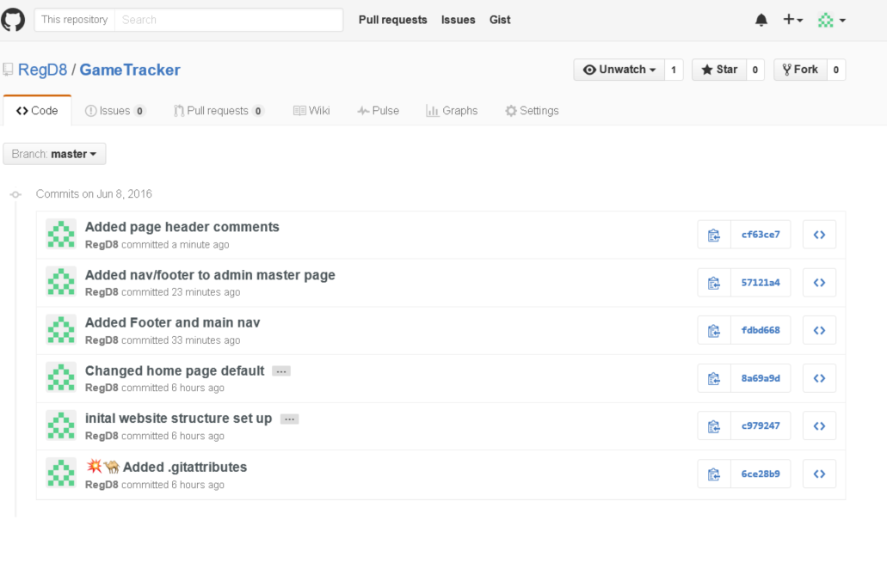

**Typography and Color**

For this project I will be using the Open Sans font for both the headings and the body font.

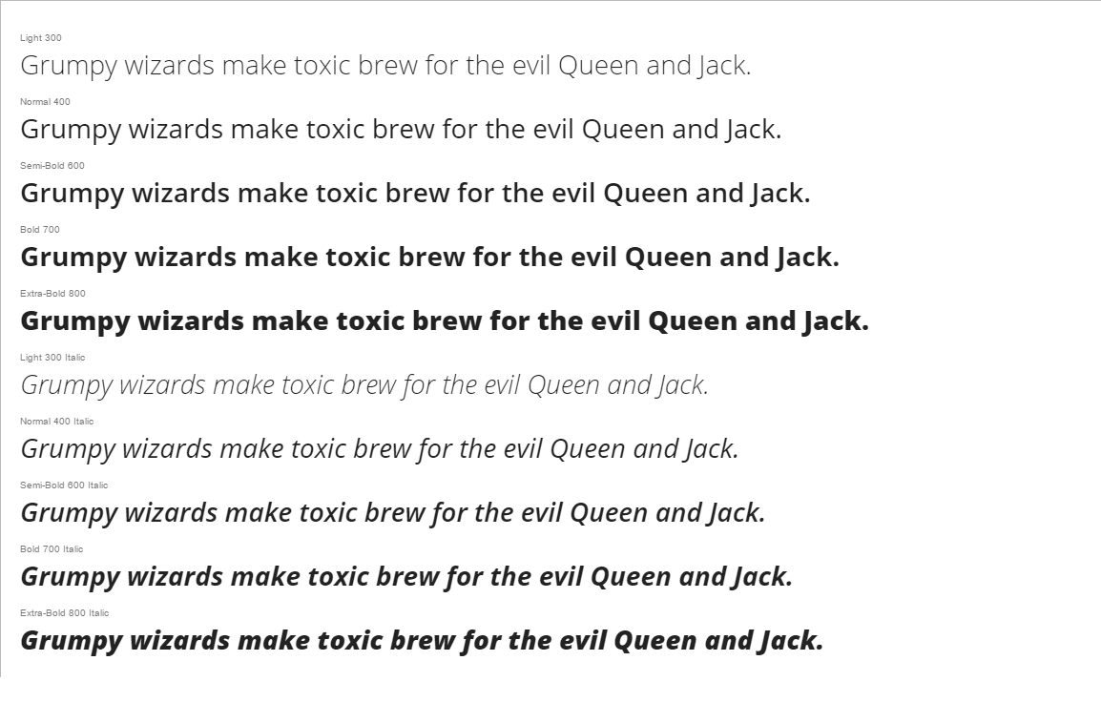

**Color Palette**

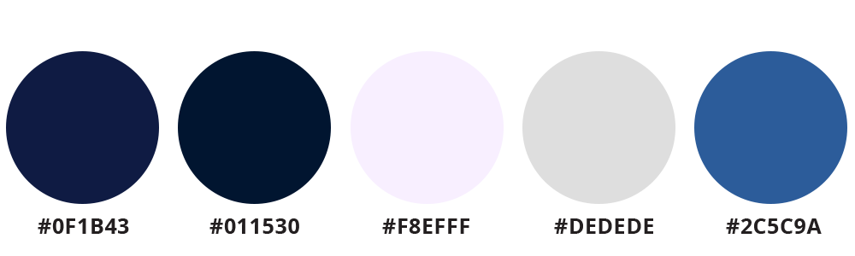

**Wireframes**

**Main Page**

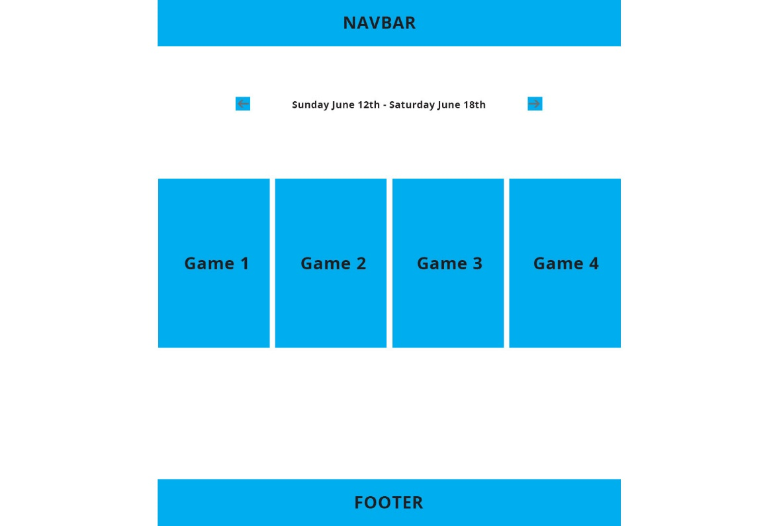

**Admin Dashboard Page**

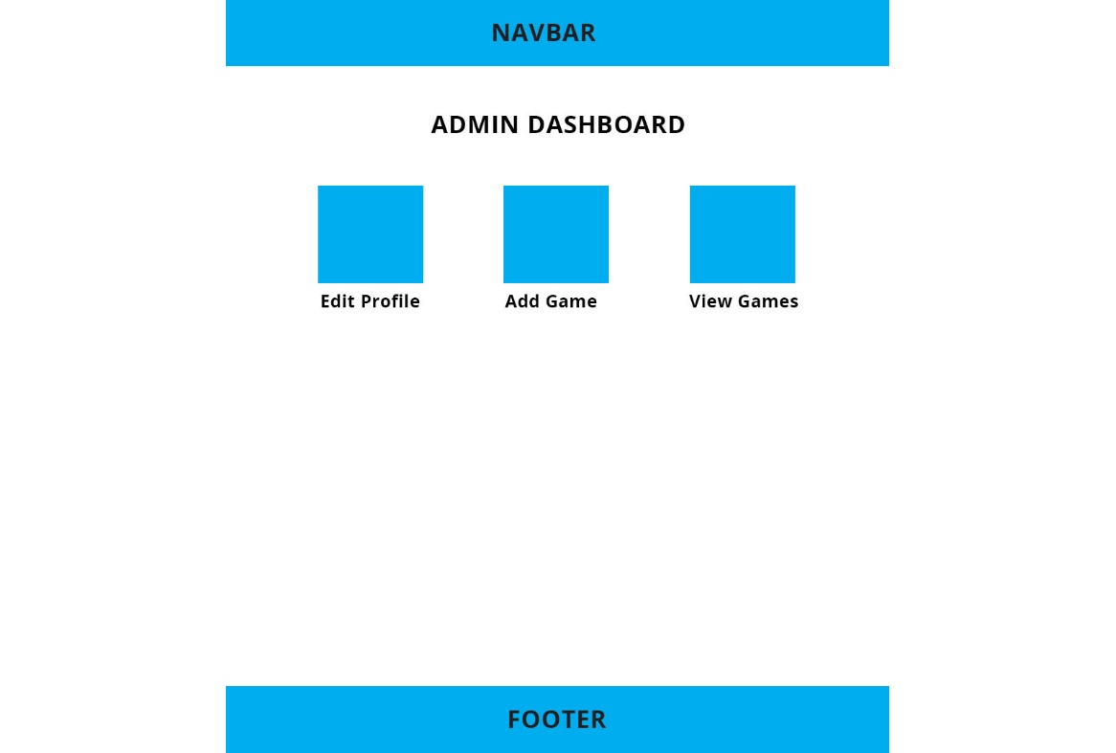

**Edit Profile Page**

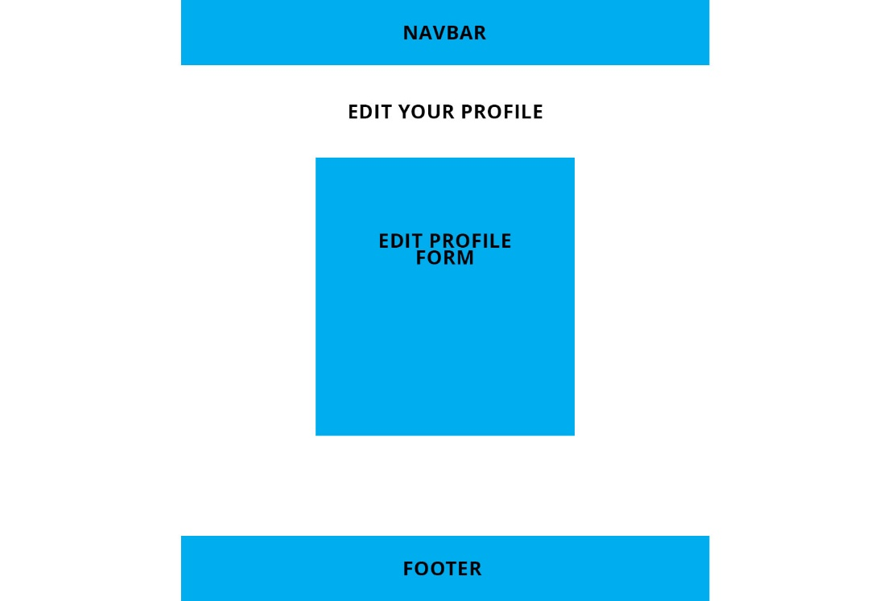

**Add game page**

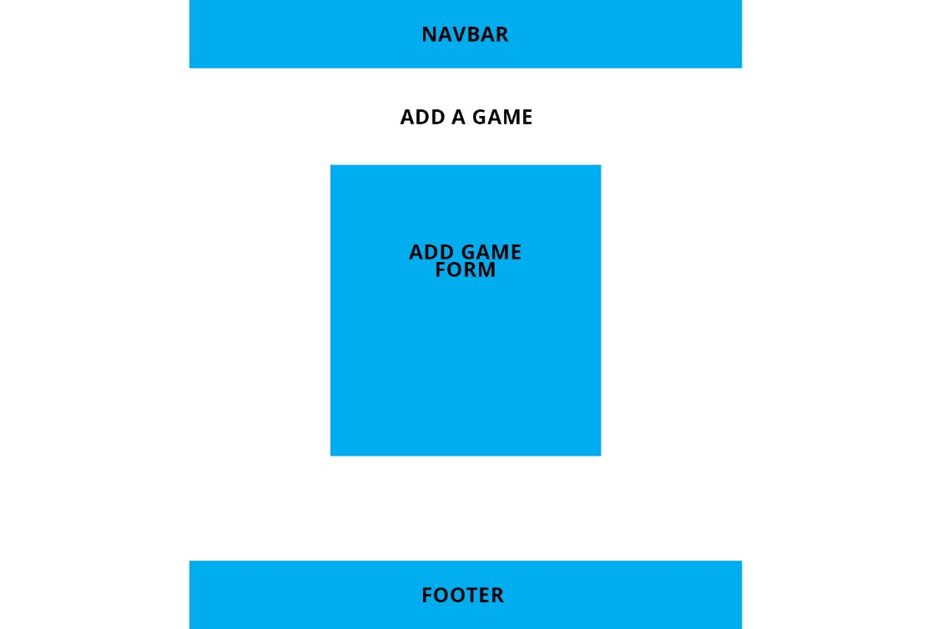

**View Games Page**

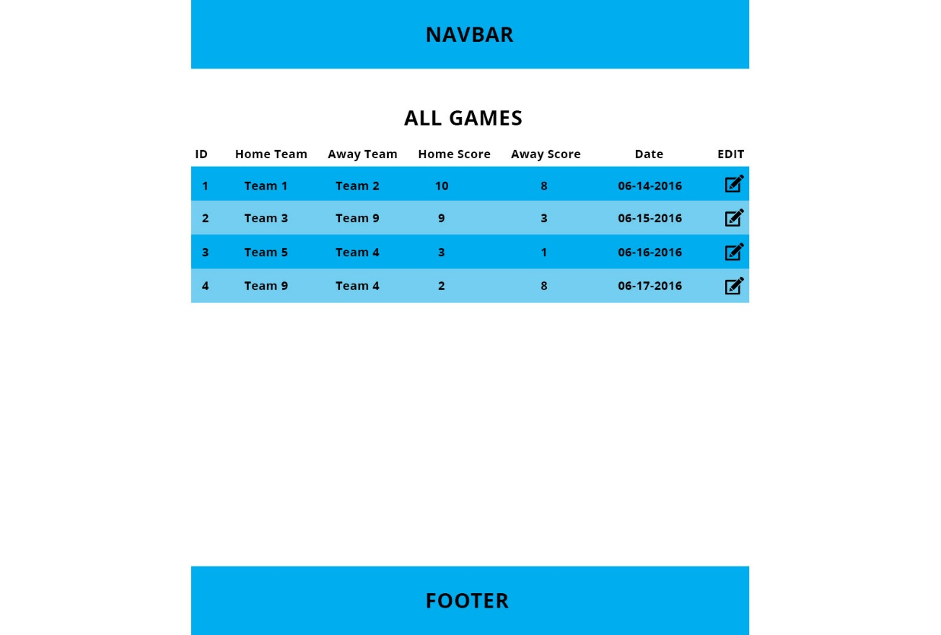

**Edit Games page**

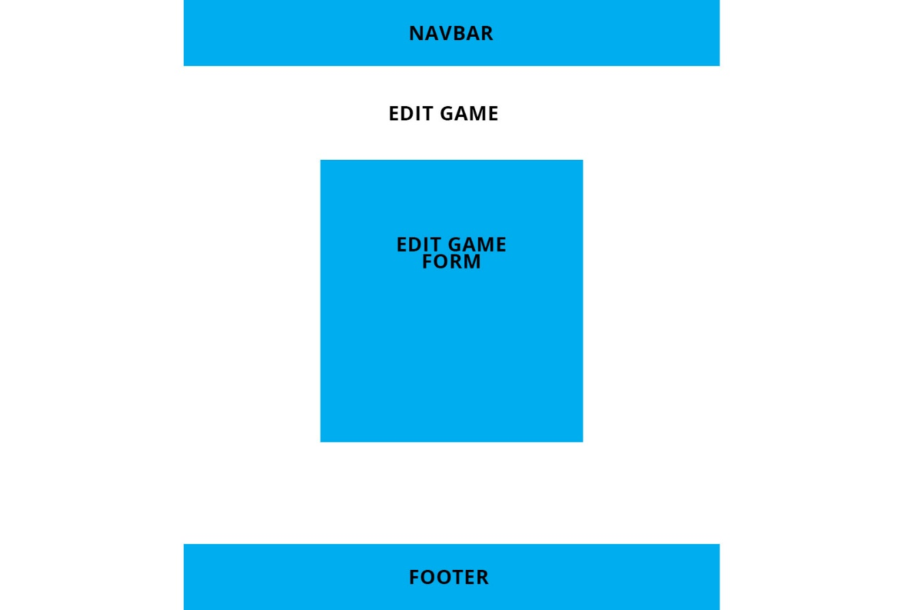

**Screen Captures**